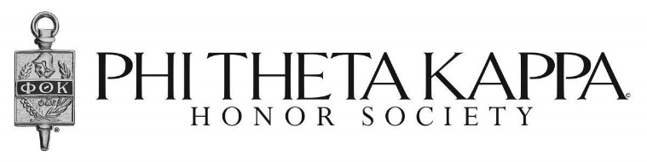
Minutes
October,18 2016 │ Meeting called to order by Wilmer Chavez____
- In Attendance

Teresa Kinney (Advisor) | Paul M. Grimaldo (ICC Officer)
Wilmer Chavez (President) | Dalmn Yoeung (Treasure)
Lauren Previtali (Honors VP)
Jonathan Roblero (Secretary)

- Introduction/Meeting Start Time
    - The meeting began at 12:35 p.m.
    - Discussed about “El dia de los muertos”
    - Discussed honors in action
    - Discussed induction ceremony
- Voting/Decisions Made
- Vote 1: Voted to voluntary for El dia de los muertos:
- Paul M. Grimaldo (ICC Officer) Made a Motion
- Spencer second
- All in favor, unanimous decision
- No opposition
- Motion passed
- Vote 2: Voted to collect the fundraiser money:
- Spencer made a motion
- Second made by Andrew
- All in favor, unanimous decision
- No opposition
- Motion passed
- Advisor comments
- Advisor asked to find another advisor.
- Budget
- Advisor stated to be around $200
- Officer Reports/Comments
- Have everyone explore the ptk website
- Committee Reports/ To be notified by email any time we are not having meetings.
- Announcements
- Dia de los muertos- Saturday, October 29,2016
- Next Meeting/ October 28, 2016 at 12:30 p.m. room 154 Founders Hall East campus.

